**Course _______Specialist______ Year __12_____**

Student name: ________________ Teacher name: ________________

Date: 24 Feb

**Task type: Response**

**Time allowed for this task: _____45______ mins**

**Number of questions: _____8______**

**Materials required:** Calculator with CAS capability (to be provided by the student)

Standard items: Pens (blue/black preferred), pencils (including coloured), sharpener, correction fluid/tape, eraser, ruler, highlighters

Special items: Drawing instruments, templates, notes on one unfolded sheet of   
A4 paper, and up to three calculators approved for use in the WACE examinations

**Marks available: __50____ marks**

**Task weighting: _10___%**

**Formula sheet provided: Yes/No**

**Note: All part questions worth more than 2 marks require working to obtain full marks.**

Q1 (3.1.1, 3.1.2, 3.1.3) (2, 2, 3 & 3 = 10 marks)

If  and  determine exactly the following. (Simplify)

1. 

|  |
| --- |
| 1. **Solution** |
|  |
| **Specific behaviours** |
| 🗸 determines conjugate of w  🗸 determines product |

1. 

|  |
| --- |
| **Solution** |
|  |
| **Specific behaviours** |
| 🗸 gives a real result  🗸 determines product |

1. 

|  |
| --- |
| **Solution** |
|  |
| **Specific behaviours** |
| 🗸 multiplies by conjugate over conjugate  🗸 evaluates numerator  🗸evaluates denominator |

1. 

|  |
| --- |
| **Solution** |
|  |
| **Specific behaviours** |
| 🗸 uses idea of conjugates  🗸 expresses both reciprocals with real denominator  🗸determines correct simplified sum |

Q2 (3.1.3) (3 marks)

Determine all possible real values of  such that 

|  |
| --- |
| **Solution** |
|  |
| **Specific behaviours** |
| 🗸 sets up one equation involving a or b  🗸 sets up two equations for a & b  🗸solves for two pairs of real values for a & b |

Q3 (3.1.14, 3.1.15) (3& 3 = 6 marks)

Consider the quadratic equation  where  are real.

1. If one root of the above equation is  , determine .

|  |
| --- |
| **Solution** |
|  |
| **Specific behaviours** |
| 🗸 sets up one equation involving c or b  🗸 sets up two equations for c & b  🗸solves for one pair of real values for c & b |

Consider the equation  where  are real.

1. If the cubic equation above has roots , determine .

|  |
| --- |
| **Solution** |
|  |
| **Specific behaviours** |
| 🗸 recognises that conjugate also a root  🗸 expands at least two linear factors  🗸solves for p,q&w |

Q4 (3.1.3, 3.1.3, 3.1.3) (2 marks)

Determine  in the form  with . (Note: diagram not drawn to scale)

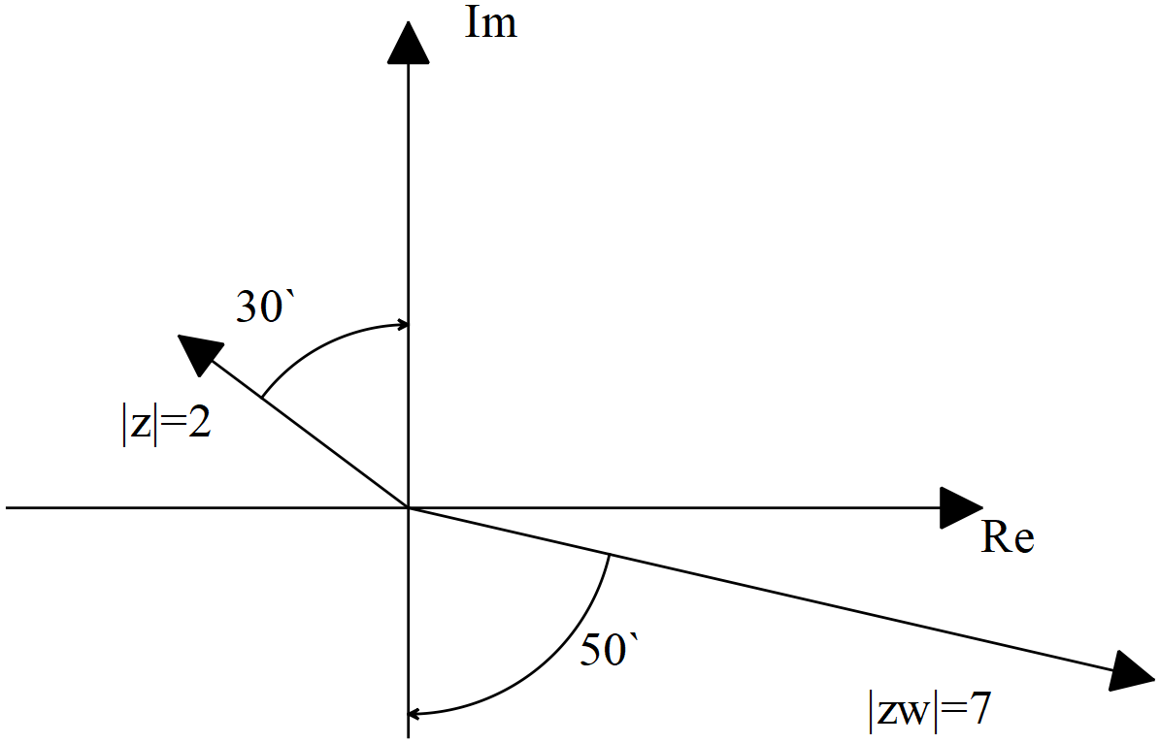

|  |
| --- |
| **Solution** |
| Accept radians or degrees |
| **Specific behaviours** |
| 🗸 determines z with principal argument  🗸 determines w with principal argument |

Q5 (3.1.10) (2, 2 & 3 = 7 marks)

Sketch the following regions in the complex plane showing major features.

1. 

|  |
| --- |
| **Solution** |
|  |
| **Specific behaviours** |
| 🗸 uses line y=-x  🗸 only drawn for Re(z)<0 (allow zero) |

1. 

|  |
| --- |
| **Solution** |
|  |
| **Specific behaviours** |
| 🗸 plots correct points  🗸 shades above perpendicular bisector |

1. Consider all the complex numbers  that satisfy , determine the maximum possible value of , giving your answer in radians correct to two decimal places.

|  |
| --- |
| **Solution** |
|  |
| **Specific behaviours** |
| 🗸 determines argument of centre of circle  🗸 uses left tangent idea for max argument  🗸solves for max argument in radians(no need to round to 2 dp) |

Q6 (3.1.7, 3.1.12) (4 & 3=7 marks)

1. Determine all the roots of  expressing in the form with .

|  |
| --- |
| **Solution** |
|  |
| **Specific behaviours** |
| 🗸 expresses right hand side into polar form  🗸 uses De Moivre’s theorem  🗸 obtains five distinct roots in polar form  🗸uses principal arguments for all roots |

1. Plot all of these roots on the diagram below.

|  |
| --- |
| **Solution** |
|  |
| **Specific behaviours** |
| 🗸 shows scale  🗸 plots one root correctly  🗸all five roots equally spaced |

Q7 (3.2.1, 3.2.2) (1, 2, 2 & 2 = 7 marks)

Consider the functions .

1. Give the defining rule for .

|  |
| --- |
| **Solution** |
|  |
| **Specific behaviours** |
| 🗸 states rule |

1. Does exist over the natural domain of ? Explain

|  |
| --- |
| **Solution** |
|  |
| **Specific behaviours** |
| 🗸 determine appropriate domain and range  🗸 shows that condition not meet for natural domain of g |

1. State the natural domain and range for .

|  |
| --- |
| **Solution** |
|  |
| **Specific behaviours** |
| 🗸 states natural domain  🗸 states range |

Consider the function .

1. Does the function ? Justify your answer.

|  |
| --- |
| **Solution** |
|  |
| **Specific behaviours** |
| 🗸 states not equal with a reason  🗸 shows that domains are different |

Q8 (3.2.3, 3.2.4) (2 & 3, 3 = 8 marks)

Consider the function  drawn below.

1. Sketch  on the axes above.

|  |
| --- |
| 1. **Solution** |
|  |
| **Specific behaviours** |
| 🗸 reflects in line y=x  🗸 inverse contains pt (5,3) |

1. Given that , determine the defining rule for .

|  |
| --- |
| **Solution** |
|  |
| **Specific behaviours** |
| 🗸 interchanges x and y to solve for inverse  🗸 states possible rules for inverse  🗸states correct rule with negative only |

1. Consider the function  where  is a positive constant. Solve in terms of , the solution(s) to .

|  |
| --- |
| 1. **Solution** |
|  |
| **Specific behaviours** |
| 🗸 sets up equation in terms of x & a  🗸factorises equation  🗸states all three x values in terms of a. |

Working out space